Q1.
Furosemide and CVT are drugs used to remove excess fluid from the body. Scientists investigated the effect of these drugs on the volume of urine produced by human volunteers. The scientists used the following method.
• They divided volunteers into three groups, A, B and C at random.
• They gave all the volunteers the same food for 3 days.
• After 3 days, they gave the volunteers in group A a tablet containing furosemide, the volunteers in group B a tablet containing CVT and the volunteers in group C a placebo (a tablet that did not contain either drug).
• They then found the mean volume of urine produced by each group in the 4 hours after taking the tablets.
Some of the results the scientists obtained are shown in Table 1.
A value of ± 2 standard deviations from the mean includes over 95% of the data.

Table 1
Group | Mean volume of urine produced in 4 hours / cm³ (± 2 standard deviations)
A  (furosemide) | 1980  (± 152)
B  (CVT) | 1201  (± 119)
C  (placebo) | 312  (± 57)
(a) All the volunteers were given the same food for 3 days.
Suggest and explain one reason why they were given the same food.
Volunteers are given the same food to determine nutritional issues that relate to new exposures of food. This is because they need to determine how the drug affects the metabolism of nutrient absorption.
(2)
(b) Using Table 1, what can you conclude about the effectiveness of furosemide and CVT in the removal of excess fluid from the body?
Furosemide was not effective. With furosemide, the average amount of urine released be hour should be between 100 to 150ml. Therefore, within four hours should be around 600ml.CVT was effective. It releases almost two hundred and fifty millilitres of urine per hour.
(2)
(c) Furosemide is sometimes used to treat high blood pressure.
Suggest how furosemide would cause a decrease in blood pressure.
It gets rid o the excess water and salt by increasing the amount of urine released thus lowering the swelling of vessels and tissues thus reducing pressure.
(1)
(d) Furosemide inhibits the absorption of sodium and chloride ions from the filtrate produced in the nephrons.
Explain how furosemide causes an increase in the volume of urine produced.
It promotes the diuresis in the diuretic loop which acts an inhibitor to the absorption of chloride ions in the ascending loop of Henle, therefore a small amount is filtered. This causes an increase in the amount produced and released.
(3)
The scientists also measured the mean rate of flow of blood plasma into the kidneys.
The results the scientists obtained are shown in Table 2.

Table 2
Group | Mean rate of flow of blood plasma into the kidneys / cm³ min^{–1}
A  (furosemide) | 380
B  (CVT) | 342
C  (placebo) | 295
(e) The mean rate of flow of blood plasma is 60% of the mean rate of blood flow into the kidneys.
How much greater is the flow of blood into the kidneys with furosemide than with group C (placebo) over the 4 hours of the investigation? Give your answer in cm³.

Answer = (380-295) = 85 cm³
(1)
(Total 9 marks)
Q2.
The graph below shows the concentration of the filtrate in different parts of one kidney tubule.
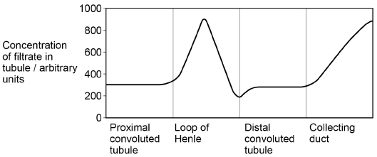
(a) More than 99% of biological molecules are reabsorbed from the filtrate in the proximal convoluted tubule.
Despite this, the concentration of fluid in this tubule remains constant.
Explain why.
This is because the convoluted tubule employs reabsorption that ensures salt and water particles are efficiently reabsorbed.
(1)
(b) Explain the shape of the curve in the loop of Henle in the graph.
The sodium ions are pumped out of the ascending limb, causing water to pass out of the descending limb. Some sodium re-enters the descending limb by diffusion causing the high concentration at the loop of Henle. (3)
(c) What is the evidence in the graph that this person was secreting antidiuretic hormone (ADH)?
Explain your answer.
Increased filtrate osmolarity.
(2)
(Total 6 marks)
Q3.
Osmoreceptors are specialised cells that respond to changes in the water potential of the blood.
(a) Give the location of osmoreceptors in the body of a mammal.
Hypothalamus.
(1)
(b) When a person is dehydrated, the cell volume of an osmoreceptor decreases.
Explain why.
Osmoreceptor cells have four proteins through which plasma membranes support diffusion from an area of high to low concentration. Therefore, if the level of osmolarity rises, the osmoreceptor cell shrinks in size.
(2)
(c) Stimulation of osmoreceptors can lead to secretion of the hormone ADH. Describe and explain how the secretion of ADH affects urine produced by the kidneys.
The release of ADH causes the kidney to release less amount of water, thus decreasing the amount of urine produce. A low level of ADH increases the amount of urine produced.
(4)
The efficiency with which the kidneys filter the blood can be measured by the rate at which they remove a substance called creatinine from the blood. The rate at which they filter the blood is called the glomerular filtration rate (GFR).
In 24 hours, a person excreted 1660 mg of creatinine in his urine. The concentration of creatinine in the blood entering his kidneys was constant at 0.01 mg cm^{–3}.
(d) Calculate the GFR in cm³ minute^{–1}.
Filtration rate = $\frac{1680mg}{0.01mg/cm3×24×60min}=116.67{cm}^{3}/min$

(1)
(e) Creatinine is a breakdown product of creatine found in muscle tissues. Apart from age and gender, give two factors that could affect the concentration of creatinine in the blood.
1. Skin colour.
2. Chronic illnesses.
(1)
(Total 9 marks)
Q4.
The graph shows changes in the amounts of water, glucose and sodium ions as fluid passes along a kidney tubule from the renal capsule to the collecting duct.
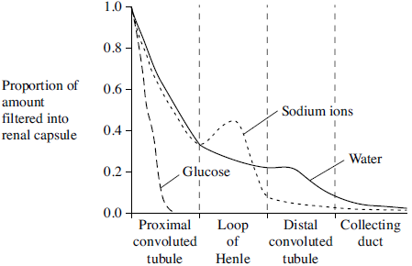
(a) Which hormone causes the decrease in the water content in the distal convoluted tubule?
Aldosterone Hormone.
(1)
(b) Explain the change in the amount of glucose.
The glucose is filtered by the glomerulus and reabsorbed back into the blood stream causing the reduction of glucose at the proximal convoluted tubule.
(2)
(c) Explain the shape of the curve for sodium ions in the loop of Henle.
The sodium ions are pumped out of the ascending limb, causing water to pass out of the descending limb. Some sodium re-enters the descending limb by diffusion causing the high concentration at the loop of Henle.
(3)
(Total 6 marks)
Q5.
- What is homeostasis?
It is the process of maintaining a stable internal, physical, and chemical environment of a living organism.
(1)
(b) Describe the role of the hormone glucagon in the control of blood sugar concentration.
It stimulates the conversion of glycogen stored in the liver to glucose to prevent the level of glucose from dropping too low.
(4)
(c) The kidney removes various substances from the blood plasma. The clearance value for a substance is the volume of blood cleared of that substance by the kidney in one minute. This clearance value can be calculated using the equation.
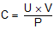

where the concentration of a substance in the blood is  the concentration of a substance in the urine is  the volume of urine produced is | P g cm⁻³  U g cm⁻³  V cm³ per minute
- Use the equation to work out the clearance value of glucose.

Clearance value of glucose = $\frac{25×0}{90}=0$
(1)
(ii) Explain how the activity of the kidney results in this clearance value for glucose.
Water is absorbed by cells lining the PCT. The active transport of glucose, mineral ions and amino acids into the tubule lowers its water potential. As a result, water enters the tubule cells by osmosis. The glucose, mineral ions and amino acids absorbed by the tubule can the diffuse into the blood capillaries that surround the PCT and water also moves into the blood by osmosis.
(3)
(Total 9 marks)
Q6.
In the kidney, ultrafiltration and selective reabsorption are two of the processes involved in the formation of urine.
(a) (i) Where does ultrafiltration occur?
The Bowman’s capsule.
(1)
(ii) Give one component of the blood which is not normally present in the filtrate.
Proteins.
(1)
(b) The kidneys remove a substance called creatinine from the blood. The rate of creatinine removal is a measure of the rate of filtration of the blood.
In one hour, a person excreted 75 mg of creatinine in his urine. The concentration of creatinine in the blood entering his kidneys was constant at 0.01 mg cm⁻³.
Calculate the rate at which the blood was filtered in cm³ min⁻¹. Show your working.
Filtration rate = $\frac{75mg}{0.01mg/cm3×60min}=125 {cm}^{3}/min$

(2)
(c) Reabsorption of glucose takes place in the proximal tubule. Explain how the cells of the proximal tubule are adapted for this function.
It has microvilli that increases the surface area of reabsorption.
The tubule is long and highly coiled to increase surface area for absorption.
(2)
(Total 6 marks)
Q7.
The graph shows changes in the amounts of water, glucose and sodium ions as fluid passes along a kidney tubule from the renal capsule to the collecting duct
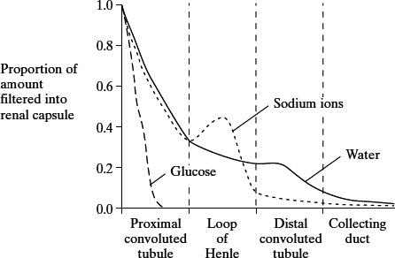
- Which hormone causes the decrease in the water content in the distal convoluted tubule?
Aldosterone Hormone.
(1)
(b) Explain the change in the amount of glucose.
The glucose is filtered by the glomerulus and reabsorbed back into the blood stream causing the reduction of glucose at the proximal convoluted tubule.

(2)
(c) Explain the shape of the curve for sodium ions in the loop of Henle.
The sodium ions are pumped out of the ascending limb, causing water to pass out of the descending limb. Some sodium re-enters the descending limb by diffusion causing the high concentration at the loop of Henle. (3)

(3)
(Total 6 marks)

